**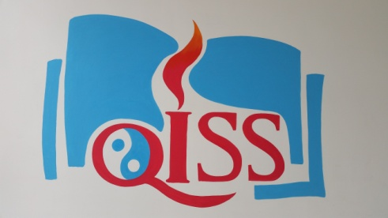**

**Grade 4 News!!**

|  |
| --- |
| October 12, 2015  **Mrs. A’s Class** E-mail: [aacevedo@qiss.org.cn](mailto:aacevedo@qiss.org.cn)  October 2014  ***Dates to Remember:***  **Oct. 15 – Healthy Shark Snack Bar**  **Oct. 17 – *Key Assignment Day***  **Oct. 18 – Soccer Camp at QISS**  **Oct. 21 –** Student Half Day  **Oct. 23 – Quarter 1 Report Cards**  **Oct. 27-28 – Student Half Day/ Parent Conferences**  **Oct. 29 – Healthy Shark Snack Bar**  **Hello Grade 4 Parents!**  http://www.funlifehappylife.com/wp-content/uploads/2015/06/peace-signs-clip-art-peace_sign_rainbow.png http://www.jesus-is-savior.com/False%20Religions/Wicca%20&%20Witchcraft/peace_3.jpg  **Happy International Peace Day!**  Our class was inspired by reading “Sadako”, a real life story of a Japanese girl who wanted to promote peace after falling ill from effects of the atomic bombing. We have decided to base our key assignment project on promoting peace in our school community.  For our key assignment project, our class will plan three (3) different proposals that will be voted upon on Key Assignment Day, which is October 17, 2015.  Grade 4 plans to create a proposal to hold the 1st Annual QISS Peace Day to promote awareness for peaceful interactions in our community. This idea is new for myself and the students, so we will need a lot of support, help and collaboration from parents as we continue to plan for this event, which we plan to hold sometime in the Spring.  C:\Users\QISS\Downloads\20150911_151657.jpg  Please visit the Grade 4 website for more pictures, information, and news about what’s happening in the Grade 4 classroom. You can translate the page into Chinese, Korean and many other languages! The blog will be updated regularly, and at the end of every month I will post all of the pictures of Grade 4 from that month. Find it here: **mrsagrade4.weebly.com/blog** |

WHAT’S GOING ON @ QISS?

Lower School Healthy Shark Snack Bar

Twice a month, the Lower School Student Council hosts the Healthy Shark Snack Bar to offer students in grade 1 to 5 with healthy options for snack time! All the lower school students have really enjoyed the selection of fresh fruit, mixed dried fruit, seaweed, nuts, cereal bar and other good healthy treats! The money earned from the Snack Bar will be used to school resources.

Of course we have to thank all the parents and volunteers who have donated items and time.

We  the Healthy Shark Snack Bar!!

**Electronic Devices**

**Electronic devices are allowed in the classroom for instructional purposes ONLY. Students may bring any device that can connect to the internet where they can practice skills related to literacy, math, science and social studies. Students are responsible for their own devices. The school will not be held responsible for lost devices.**