**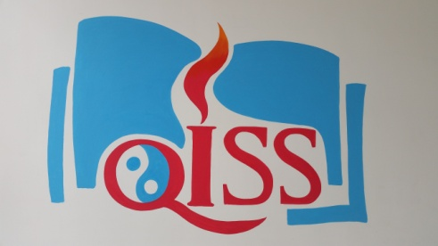**

**Grade 4 News!!**

|  |
| --- |
| September 21, 2015  **Mrs. A** E-mail: [aacevedo@qiss.org.cn](mailto:aacevedo@qiss.org.cn)  **Hello Grade 4 Parents!**  http://www.funlifehappylife.com/wp-content/uploads/2015/06/peace-signs-clip-art-peace_sign_rainbow.png http://acelebrationofwomen.org/wp-content/uploads/2013/09/International_Day_Of_Peace_Wallpapers.jpg http://www.jesus-is-savior.com/False%20Religions/Wicca%20&%20Witchcraft/peace_3.jpg  **Happy International Peace Day!**  Our class was inspired by reading “Sadako”, a real life story of a Japanese girl who wanted to promote peace after falling ill from effects of the atomic bombing. We have decided to base our key assignment project on promoting peace in our school community.  For our key assignment project, our class will plan three (3) different proposals that will be voted upon on Key Assignment Day, which is October 17, 2015.  Grade 4 plans to create a proposal to hold the 1st Annual QISS Peace Day to promote awareness for peaceful interactions in our community. This idea is new for myself and the students, so we will need a lot of support, help and collaboration from parents as we continue to plan for this event, which we plan to hold sometime in the Spring.  C:\Users\QISS\Downloads\20150911_151657.jpg  Please visit the Grade 4 website for more pictures, information, and news about what’s happening in the Grade 4 classroom. You can translate the page into Chinese, Korean and many other languages! The blog will be updated regularly, and at the end of every month I will post all of the pictures of Grade 4 from that month. Find it here: **mrsagrade4.weebly.com/blog**  October 2014  ***Dates to Remember:***  **Sept. 24 – Healthy Shark Snack Bar**  **Oct. 1-9 –** ChineseNational Holiday Break  **Oct. 17 –** Key Assignment Day  **Oct. 21 –** Student Half Day  **Oct. 23 – Quarter 1 Report Cards**  **Oct. 27-28 – Student Half Day/ Parent Conferences** |

WHAT’S GOING ON IN GRADE 4?

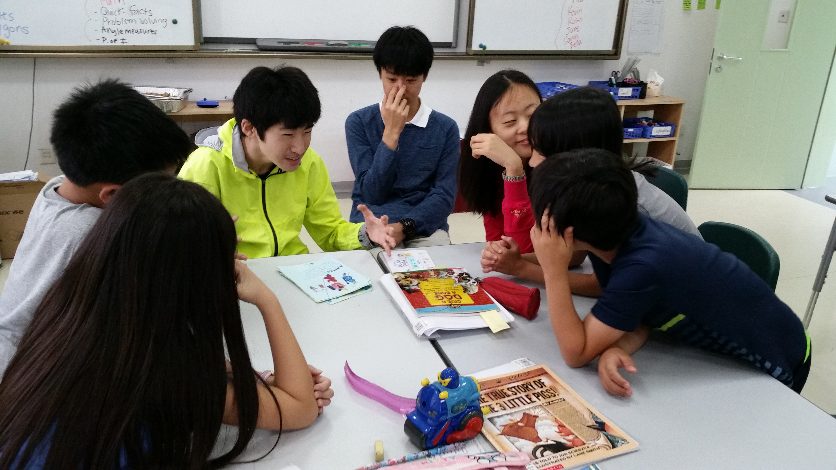

Grade 4 student were delighted with children's stories written by Ms. Pinyan's Grade 9A World History I class. The Grade 9 students were able to practice their presentation skills while the Grade 4 students were able to learn about history in a fun and new way.

**Electronic Devices**

**Electronic devices are allowed in the classroom for instructional purposes ONLY. Students may bring any device that can connect to the internet where they can practice skills related to literacy, math, science and social studies. Students are responsible for their own devices. The students are encouraged to leave their devices inside the classroom during the day. The school will not be held responsible for lost devices.**