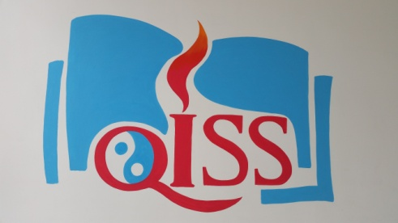

**Grade 4 News!!**

|  |
| --- |
| September 7, 2015  **Mrs. A** E-mail: [aacevedo@qiss.org.cn](mailto:aacevedo@qiss.org.cn)  September 2014  ***Dates to Remember:***  **Sep. 3-4 -** No School  **Sep. 8 –** Student Half Day  **Sep 11 –** Q1 Progress Reports |

**Hello Grade 4 Parents!**

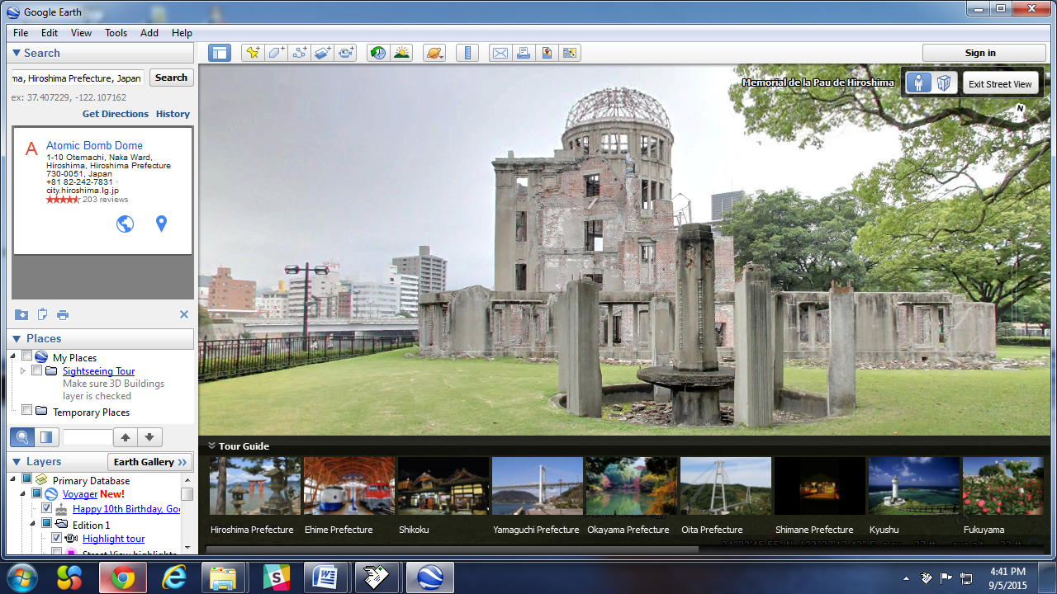

To begin our Point of Inquiry and Literacy Units, we took a virtual field trip to Hiroshima, Japan to visit the Hiroshima Peace Park. The Hiroshima Peace Park is a memorial site in remembrance of the all those who perished after the atom bombing in Hiroshima in August 1945.

We have been reading “Sadako”, a true-story novel about a young girl who fell ill after the atom bombing. The students have been able to discuss various elements of the story, including studying the characters and how they changes during the story. The students have been able to use intelligence and courage to understand material that can be sad at times.

We are relating the cultural aspects we have learned from reading “Sadako” to elements of our own cultures. Parts of one’s culture are language, dress, food, music and environment.

We have been able to relate elements of cultural environments to different landforms present in our home countries.

Please visit the Grade 4 website for more pictures, information, and news about what’s happening in the Grade 4 classroom. You can translate the page into Chinese, Korean and many other languages! The blog will be updated regularly, and at the end of every month I will post all of the pictures of Grade 4 from that month. Find it here: **mrsagrade4.weebly.com/blog**

MEET OUR SPECIALISTS!

***ART with Ms. Nadine Bouliane***



***PHYSICAL EDUCATION***

***with Mr. Matthew Krakowski***

C:\Program Files\Microsoft Office\MEDIA\CAGCAT10\j0299763.wmf

***MUSIC with Mr. Adam Solomon***

***CHINESE with Ms. Carrie Huang, Ms. Emily Zhang and Ms. Kelly Du***

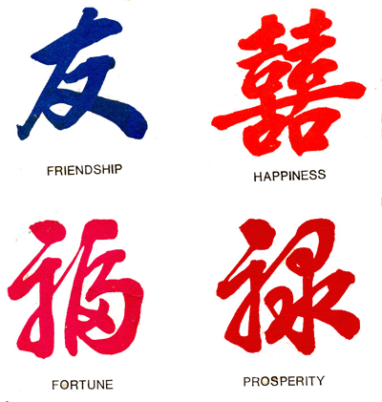

***ELL with Ms. Julie Kanel***

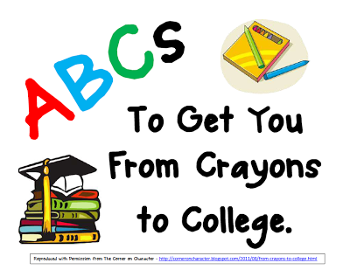

***Library with Ms. Brooke Bertholet***

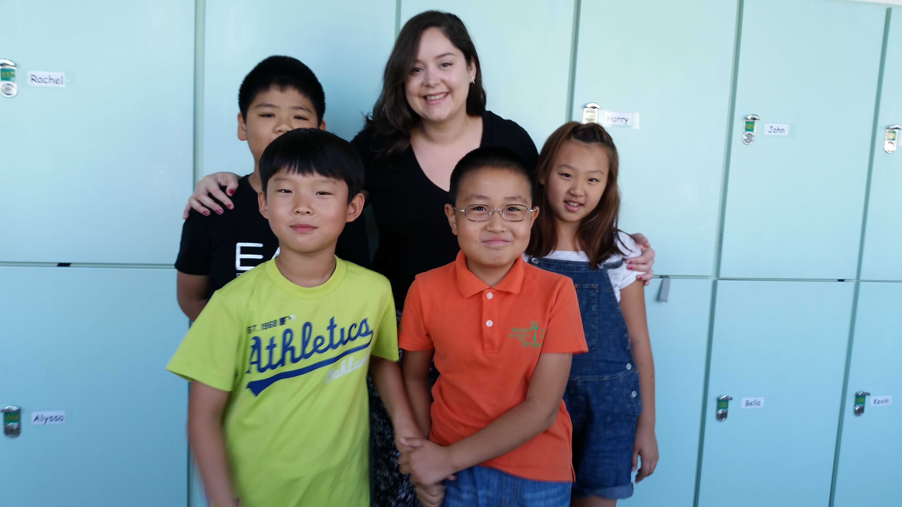

**Welcome to Grade 4!**

This year we have welcomed a new teacher and four new students to Grade 4. We are thrilled to have Mrs. A, Sarah, June, Oliver and Harry join QISS and our class! We look forward to teaching them how to use the ELSRs to become global citizens and lifelong learners!